JCR paper |  |  | Chinese paper
 | Method | Description |  | Method | Description
Study 1 Archival Study | Design | Second data of stock performance | Experiment 1a | Design | 6 conditions (one vs. two vs. three vs. four vs. five vs. six)
 | Material | ─ |  | Material | 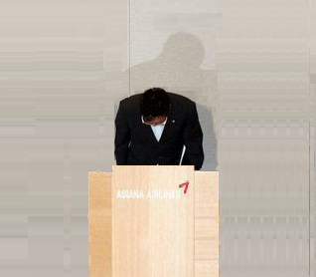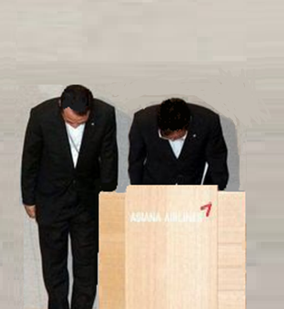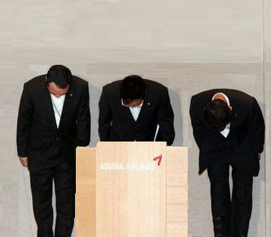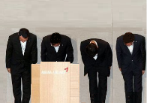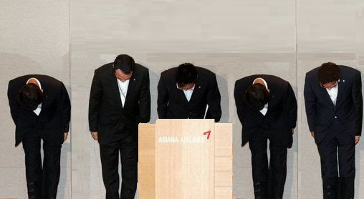  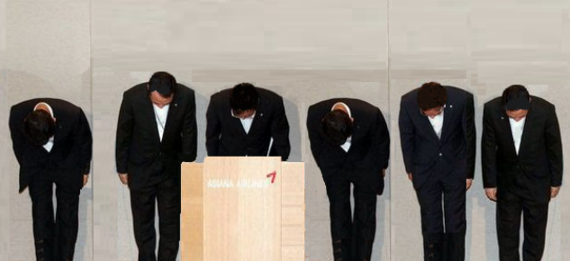
 | Company name | ─ |  | Company name | Yuke Company (宇科有限公司)
 | DV | Abnormal return |  | DV | Scale of TRIM (twelve items)
 | Collection time | September 2015 (the first time) and December 2016 (the second time) |  | Collection time, place, country of participants | Jinan University, China; April 2016; Chinese
Study 2 Real Behavioral Lab Experiment | Design | 2 conditions (apology letter with ‘I’ pronoun and one person’s signature vs. apology letter with ‘We’ pronoun and a team’s signature) | Experiment 1b | Design | 2 conditions (one vs. four)
 | Material | Procedure: A wrongdoing made by the experimenter Participants went away without an apology from the experimenter An apology email sent to participants and inviting them to come back next week |  | Material
 | Company name | ─ |  | Company name | Amiblue Company
 | DV | Response rate |  | DV | Adopting the Resource Allocation Task, participants were given 10 ballots and told that they could anonymously divide the ballots between Amiblue Company (the apologizing company) and Apearl Company. Only the winner who have higher balls can get the opportunity to cooperate with the university team.
 | Collection place, time, language | University of Toronto, Canada; February 2018; English |  | Collection place, time, language | Jinan University, China; April 2016; Chinese
Study 3 Apology on Twitter | Design | 4 conditions (one person left vs. one middle [a female] vs. one right vs. three) | Experiment 2 | Design | 2 conditions (one vs. three)
 | Material | 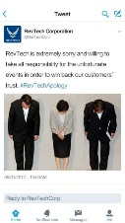 |  | Material | 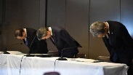
 | Company name | RevTech Corporate |  | Company name | Amiblue Company
 | DV | TRIM scale |  | DV | Three items of the forgiveness scale
 | Collection place, time, language | MTurk, USA; February 2019; English |  | Collection place, time, language | Jinan University, China; July 2016; Chinese
Study 4 Apology on Facebook | Design | 5 conditions with 2 (one vs. four) X 2 (CEO vs. no CEO) and a no-apologizer control condition | Experiment 3 | Design | Four conditions with a 2 (one vs. three) X 2 (picture vs. no picture) between-subjects design
 | Material | 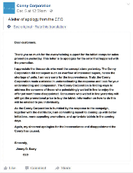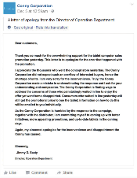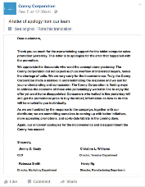  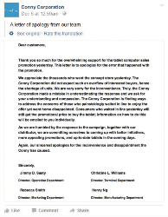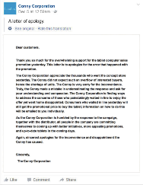 |  | Material | 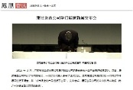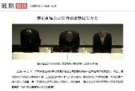  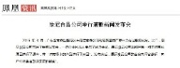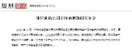
 | Company name | Conny Corporation |  | Company name | Kangni Company (康尼公司)
 | DV | Three items of the forgiveness scale, four items of the integrity scale, and one item of satisfaction. |  | DV | Four items of the forgiveness scale
 | Collection place, time, language | Mturk, USA; January 2019; English |  | Collection place, time, language | Jinan University, China; August 2016; Chinese
Study 5 Entitativity study | Design | 3 conditions (one vs. low entitative three vs. high entitative three) | Experiment 4 | Design | 3 conditions (one vs. three people vs. three people described as a team)
 | Material | 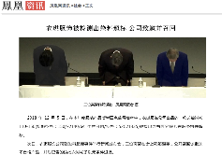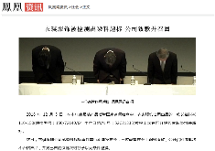  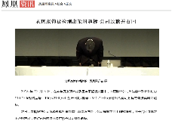  [Manipulation of entitativity: In the high entitativity condition, three people wear suits with the same color, while in the low entitativity condition, they wear different colors.] |  | Material | [Manipulation of entitativity: In the high entitativity condition, three people are called as “a team”, while in the low entitativity condition, they are called as their separate positions.]
 | Company name | Yeeky Corporation (衣琪公司) |  | Company name | Yuke Company (宇科有限公司)
 | DV | Three items of the forgiveness and one item of acceptance |  | DV | Four items of the forgiveness scale
 | Collection place, time, and language | Zhongnan University of Economics and Law, China; December 2018; Chinese |  | Collection place, time, language | Jinan University, China; January 2017; Chinese

